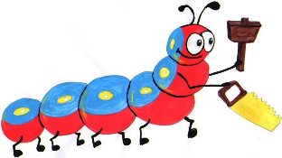

Lyng Primary School Knowledge Organiser

Design Technology



Anglo Saxons

Autumn

Year 4

Topic: DT

|  |  |
| --- | --- |
| What Goldilocks and Step On words will I use? | |
| **Spelling** | **Defintion** |
| Join | to bring in contact, connect, or bring or put together |
| Design | to generate, develop and communicate ideas for a product. |
| Wooden | made of wood (branches of a tree or shrub, and lying beneath the bark) |
| Natural | Existing in or derived from nature; not made or caused by [humankind](https://www.google.com/search?sca_esv=581933055&rlz=1C1GCEA_enGB909GB909&q=humankind&si=ALGXSlYl_e3TsZvERASNGAvnwCgji4ltTzk6GyFl1d6GAupL545SoAxdQfGWPvZJKyWqBYH5qN79Oy0W6MzLM1OCZfrBeuEC6e_SYNhYeYOITAUOquxiglI%3D&expnd=1). |
| Village | A group of houses and associated buildings, larger than a [hamlet](https://www.google.com/search?sca_esv=581933055&rlz=1C1GCEA_enGB909GB909&q=hamlet&si=ALGXSlZs_yOcjbcvFwhB4E04oe9Y8cc_fdW40ROPwCRzgI8dTCjhEXT7E358BrZ8EvzEzdS5RIhIFDc5Sz3fl92WJekivEaKVQ%3D%3D&expnd=1) and smaller than a town, situated in a rural area. |
| Thatch | cover (a roof or a building) with straw or a similar material. |



**Design Brief for pupils:**

* Explore Anglo Saxon homes using ipads and library books
* Generate designs for a new Anglo Saxon home using LETs SAY……..
* Experiment with and practise creating pop-up cards using different mechanisms.
* Make an effective Anglo Saxon model home using joining techniques.
* Evaluate product and discuss any improvements.

**Purpose:** LETs SAY we are Anglo Saxon builders and we have been asked to build a house in the kingdom of Mercia   
**Audience:** Children in other year groups, parents, and teachers

Autumn Term

Construction

Create a building

|  |
| --- |
| Skills and techniques |
| * Take inspiration from photos and videos of previous Anglo Saxon buildings * Generate ideas for design. * Explore designs and evaluate effectiveness. * Analyse pre-existing Anglo Saxon style homes * Create designs building on ideas. * Select appropriate materials * Choose suitable techniques to construct and join a product * Cut materials accurately and safely. * Measure and mark out to the nearest millimetre * Evaluate product and discuss how to improve product. |

**Thatched roof (used cow dung)**

**We will use clay as an**

**alternative also weaving.**



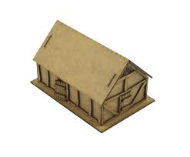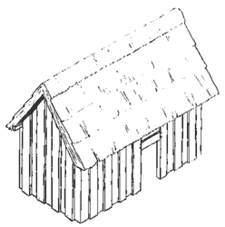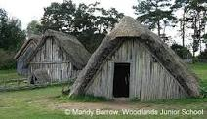

**Agreed outcome:**

To design, make, evaluate, and build a model Anglo Saxon home